TEAM ID : LTVIP2026TMIDS72376
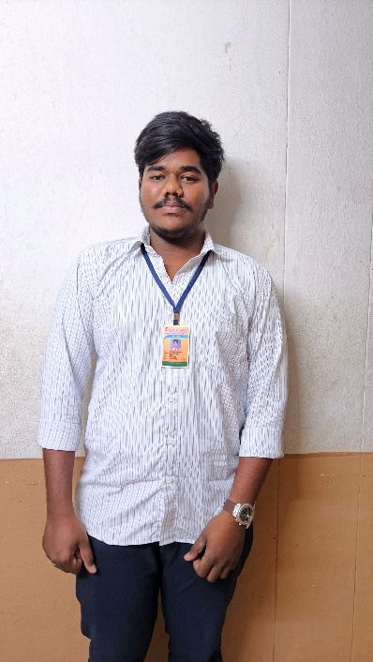
TEAM LEADER: SABBITHI PUNEETH KUMAR

Reg id: SBAP0052571
MAIL ID : Sabbithipuneethkumar@gmail.com
TEAM MEMBERS :
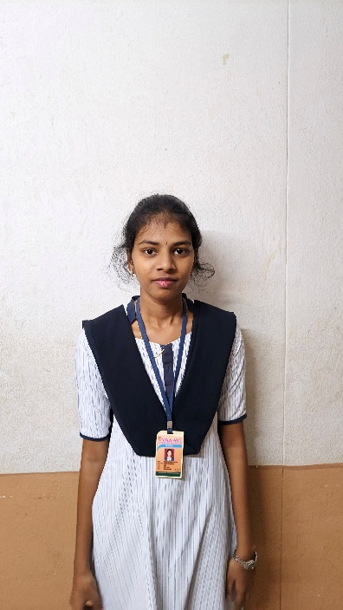
NAME: SIDDA LAKSHMI TEJASWI
Reg id : SABP0052662
MAIL ID: tejaswisidda999@gmail.com

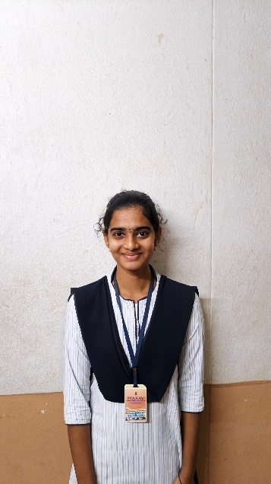
NAME: ULUSU NAGA VARALAKSHMI
Reg id: SABP0052660
MAIL ID: ulusunagavaralakshmi@gmail.com
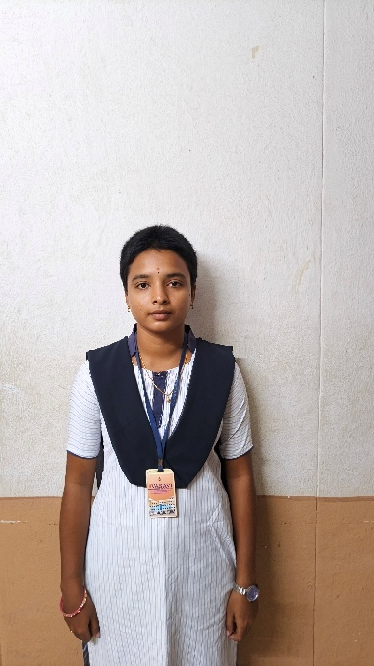
NAME: MUNGARA SWARNALATHA
Reg id: sabp0052654
MAIL ID: mungaraswanalatha7@gmail.com

